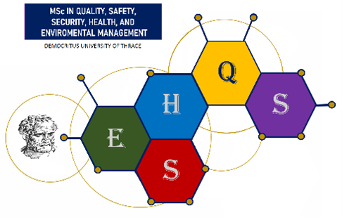
RECENT
PHOTO

Ref. No.:

POSTGRADUATE PROGRAMME APPLICATION
“Chemical Industry: Quality, Environmental, Health and Safety Management”
(MSc in “Quality, Environmental, Health and Safety Management”)
(MSc in Quality, Safety, Security, Health, and Environmental Management)

SURNAME:
NAME:
FATHER’S NAME:
MOTHER'S NAME:
CORRESPONDENCE ADDRESS:
POSTCODE:
CITY:
REGION:
CONTACT NUMBER:
EMAIL:
DATE OF BIRTH:
PLACE OF BIRTH:
ID CARD NUMBER:
ID ISSUE DATE:
ISSUING AUTHORITY:
NATIONALITY:
MARITAL STATUS:
TAX IDENTIFICATION NUMBER (TIN):
YEAR OF GRADUATION:
DEPARTMENT:
SCHOOL:
UNIVERSITY:
FOREIGN LANGUAGES:
*(To be completed by uniformed personnel only)
ATTACHED SUPPORTING DOCUMENTS
- ……………………………………………………………………………………………………………………………….
- ……………………………………………………………………………………………………………………………….
- ……………………………………………………………………………………………………………………………….
- ……………………………………………………………………………………………………………………………….
- ……………………………………………………………………………………………………………………………….
- ……………………………………………………………………………………………………………………………….
- ……………………………………………………………………………………………………………………………….
- ……………………………………………………………………………………………………………………………….
- ……………………………………………………………………………………………………………………………….
- ……………………………………………………………………………………………………………………………….
ALL DOCUMENTS MUST BE SUBMITTED TO THE SECRETARIAT BY THE APPLICATION DEADLINE

